Ideation Phase
Brainstorm & Idea Prioritization
Date | 8 October 2026
Student Name | OviyaShree
Project Name | Metro Ticket Generating System in ServiceNow
Maximum Marks

Brainstorm & Idea Prioritization
The brainstorm focuses on digitizing metro ticket booking in ServiceNow: a guided Service Catalog booking form, automated fare calculation, QR code ticket generation, station mapping, notifications and future analytics.
Idea Group | Priority
Scoped ServiceNow application | High
Service Catalog item for ticket booking | High
Fare calculation logic script | High
QR code generation of digital tickets | High
Station details mapping | High
Flow Designer and Notifications | Medium
UI Pages | Medium
Digital payment adoption (UPI, cards, wallets) | Medium
Data analytics and reports | Low
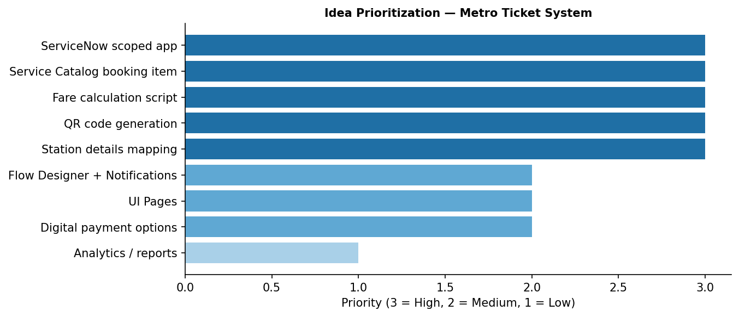
Figure 1: Prioritized brainstorm representation based on the project ideas.

